# 

EXERCISE,

INHERITANCE – GETTING STARTED

# Exercise 4, Inheritance – getting started

## Objective

The primary objective for this lab is to enable you to derive new types and to add specialist functionality.

## Overview

The lab introduces some of the basic concepts of the inheritance story. As mentioned in the associated session, in order to implement inheritance, you must first have a class that provides the fundamental definition or behavior you need. In this lab we will play about with circular shapes.   
This practical will be built on two chapter’s time.

### Step by step

1. Create a new Console application called **Lab04**.
2. Create the following class structure  
   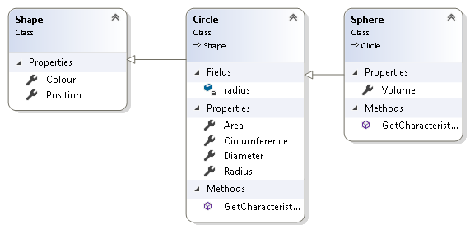
3. As you can see, **Circle** extends **Shape** and   
   **Sphere** extends **Circle.**
4. ***Position*** is of type **Point** which is a struct with built-in x and y.
5. ***Colour*** is of type **Color**

Both **Point** and **Color** are from the ***System.Drawing*** namespace but Console apps do not reference *System.Drawing.dll*. You therefore need to add reference to System.Drawing   
(see below).

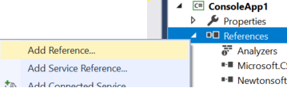

And then select the reference.

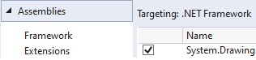

**Tip**: Use **Math.PI** to get the value of **PI**.   
You will need this to calculate the area and circumfrance of circle.  
  
Volume of an sphere is calculated as **4/3 * PI * R3**   
(R to power of 3).You can use the Math.pow(R,3) fuction or   
R * R * R.

1. Create a constructor for Shape to set its colour and position
2. Create property methods for each of the fields (colour, radius…) as indicated in the class diagram above.
3. The **GetCharacteristics ()** method returns a *string* containing all the attributes of the shape. It will be up to the caller how to display this information.
4. Create a few shape types in Main() such as Rectangle, Circle and Sphere.
5. Print the characteristics of the Rectangle, Circle and Sphere objects which you've created.
6. Create a List<Shape> called **shapes** in the main()
7. Add the shapes which you created earlier into the *shapes* list.
8. Create a **foreach** loop to scroll through each shape and print its colour and position (x,y).  
     
   How does this work?! How can we store a shape like Rectangle in a list of Shapes? All will be revealed in the next chapter.

**\*\* End \*\***